A286-Asia-Indus-Mehgarh-Figurine-Female-Terracotta-4800 BCE–3500 BCE- Merhgarh Period III

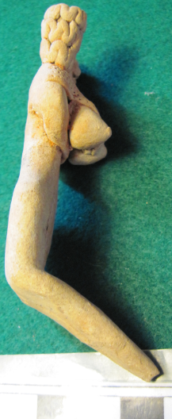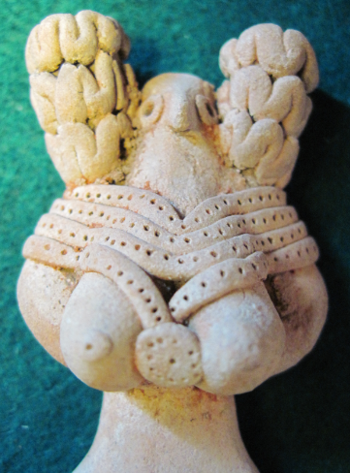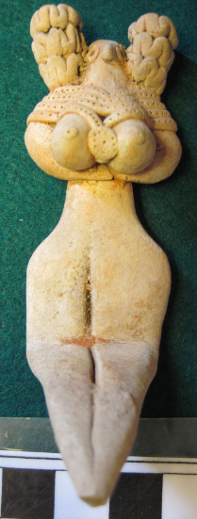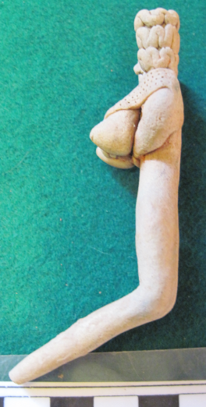

**Case No.: 3**

**Accession Number: A286**

**Formal Label:** Indus-Mehgarh-Figurine-Female-Terracotta-Mehgarh Period III-4800 BCE–3500 BCE

**Display Description:**

The Neolithic Mehrgarh site (Baluchistan, Pakistan) along the Bolan river period I and II ca 7000-5000 BCE is situated in the Kachi plain. Several superimposed 4-room buildings were built with unbaked clay bricks (60 x 12 cm, with finger impressions). Painted polychrome geometric plaster suggests that surfaces of external walls were painted.

The Mehrgarh Period II (5500 BCE–4800 BCE) and Mehgarh Period III (4800 BCE–3500 BCE) were ceramic Neolithic, using pottery, and later chalcolithic. Period II is at site MR4 and Period III is at MR2 (Sharif and Thapar 1999: 254-256). Ceramic manufacturing produced detailed female terracotta figurines some of which were decorated with paint and had diverse hairstyles and ornaments lke the current example.

**LC Classification:**  GN776.32.P18

**Date or Time Horizon:** Mehgarh Period III (4800 BCE–3500 BCE)

**Geographical Area:** Mehgarh, Baluchstan, Pakistan

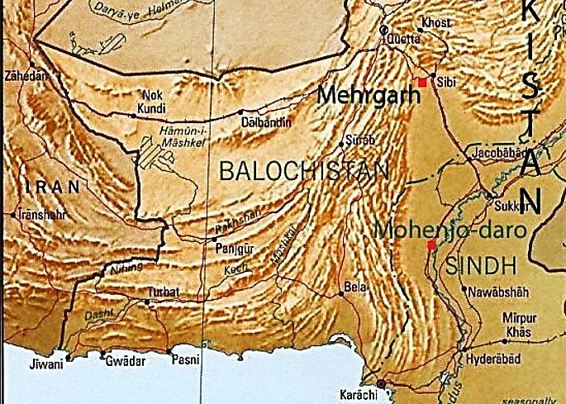

**Map showing location of Mehrgarh in Baluchistan. From** <https://upload.wikimedia.org/wikipedia/commons/f/fc/Mehrgarh_pakistan_rel96.JPG>

**GPS Coordinates:** 29º23'59" N 67º36'1" E

**Cultural Affiliation: Pre-**Indus Valley Civilization

**Medium:** terracotta

**Dimensions**: 96.09 mm, 3.783 in  
**Weight: 26 g, 7/8 oz**

**Provenance: Old English Collection**

**Condition:** original

**Discussion:**

Mehrgarh is the oldest archaeological site in Pakistan and is the second oldest Indus Valley site after Bhirrana, according to Archaeological Survey of India report of 2014. It has an area of over 250 hectares, and is the oldest farming settlement of Indus Valley Civilization. Mehrgarh was founded ca 7000 BCE and was abandoned ca 2500 BCE with the rise of Moenjo-daro’s urbanized phase.

**References:**

Jarrige, Jean-François. 2013. Mehrgarh: Neolithic period seasons 1997-2000, Pakistan / Jean-François Jarrige, Catherine Jarrige, Gonzague Quivron; with an appendix by Luc Wengler; with the collaboration of David Sarmiento Castillo. Mémoires des missions archéologiques françaises en Asie centrale et en Asie moyenne. Série indus-Baluchistan ; t. 15. Paris: Éditions de Boccard.



Sharif, M and B. K. Thapar, B. K. 1999. "Food-producing Communities in Pakistan and Northern India". In V. M. Masson, A. H. Dani and Janos Harmatta, History of civilizations of Central Asia. (New Delhi: Motilal Banarsidass), pp. 254–256.